**Project Summary**

Recently, researchers have found new methods for UAV(Unmanned Aerial Vehicle) navigation. Instead of using laser and radar sensors, they improve methods to use inertial navigation, satellite navigation, and vision-based navigation.

In this project, I investigate the vision-based navigation method. The UAV can calculate the location by using sensors and recognize surrounding objectives . Then, it can design the path to move.

Several visual sensors have been utilized for vision-based navigation including: (a) Monocular cameras, (b) Stereo cameras, (c) RGB-D(Red, Green, Blue-Depth) cameras, and (d) Fisheye cameras. Stereo cameras are used to find the depth. RGB-D cameras are commonly used in indoor environment and Fisheye cameras are preferred to be used for obstacle avoidance. In my project, I will choose Monocular cameras because the UAV needs to capture the image of map and has no need to calculate the depth.

Mapping and localization can be classified into three categories: mapless system, map-based system, and map-building system.

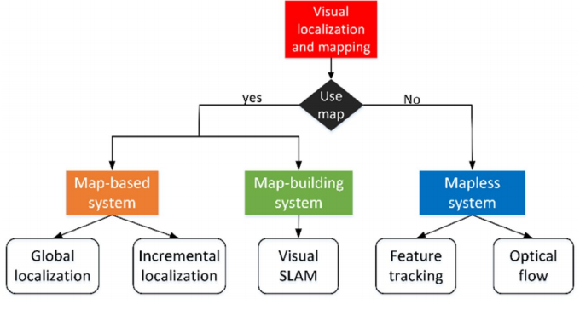

In this project, the UAV is proposed to recognize roads and plan the moving path according to a given map. Hence, the map-based method is employed in this project and use occupancy grids maps.

As for detection, there are two methods widely used. The first one is one-stage object detection, such as Yolo, which is suitable for real-time performance. The other method is two-stage object detection, including Aidlux, Darklabel, which has higher accuracy but with lower frame per second (fps) than one-stage.

The performance of one-stage method will be investigated for high fps detection when a lot of images are processed continuously.

**Project Objectives**

* Compare the difference between types of machine vision software and algorithms (Pytorch, Yolo OpenCV or Matlab).
* Design a UAV-vision model that is able to detect and navigate road segments.
* Compare the performance of the proposed method in this project with other systems that use 3D sensors and algorithm of mapping.
* Train the model by using different sets (For example, training set, validation set, test set).
* Investigate the effect of changing parameters, algorithms, and environment.
* Improve the model and get the best result from the model.

**Gantt Chart**

To achieve project objectives, the following Gantt chart proves the timely planned milestones throughout the project:

